Releases notes v1.08
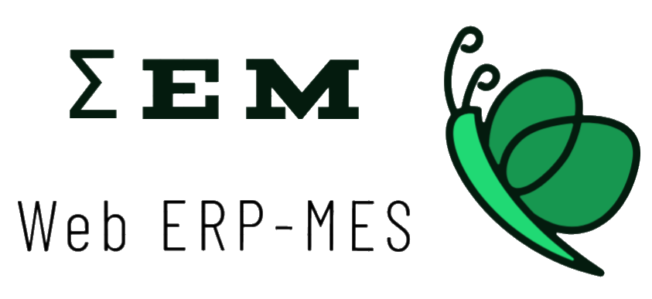

Releases notes
v1.08
Bugs & Change 3
Improvement 4
RGPD Rules #299 4
if Iframe mode on WEM #297 4
Add internal & External comment for lines #293 5
Take photo of packtage befor delevery #290 6
General Conditions of Sale (CGV) #294 7
Ad drawing file of product #308 8
Add preferred supplier #313 8
In purchase requests, display only the products concerned by the supplier #314 8
Make same UI from Task list to purchase and problem with conversions #315 8
No productive task, change UI #316 9
change statu if is an internal order #323 9
Create red case if all stock are low #319 9
Display of stocks and requirements #321 10
Change statu workflow, if is and internal order #327 10
Create purchase order, if stock for component is low as needed #320 10
Desactivate new order button, if need is null #332 10
Create in/out stock #318 11
Be able to manage tasks for sub-assembly #334 12

Bugs & Change

#250 - Multiple insert, on factory page, if not
#302 - Rename accounting to accounting
#298 - Check if we can use Lightblue Theme
#296 - Use provider for factory settings
#295 - Use middleware for check factory setting
#300 – Fix English traduction
#295 - Use middleware for check factory setting
#309 - Error Exception - Trying to access array offset on value type null
#305 - Use middleware for check statu setting
#307 - Need one favicon
#317 - Fixe picture width
#322 - product load on update line
#304 - User laravel service for get selected values
#326 - Order line qty to 0 create bug on task manage
#328 - the qty is not taken correctly
#329 - production.ERROR: Undefined property: stdClass::$qty
#330 - Attempt to read property "purchaseLines" on null
#331 - Attempt to read property "drawing_file" on null
#335 - Exclude internal orders from the order total present in graph

Improvement

RGPD Rules #299
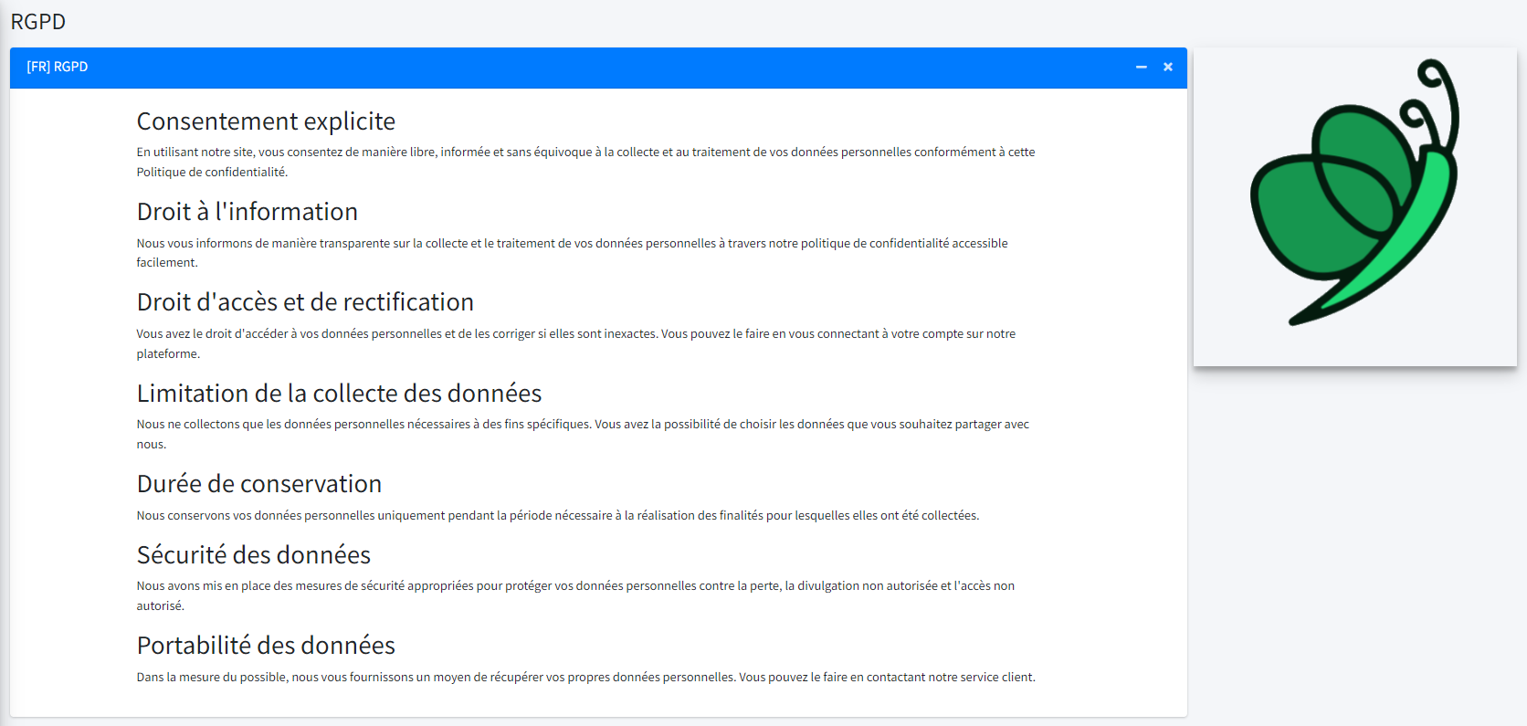

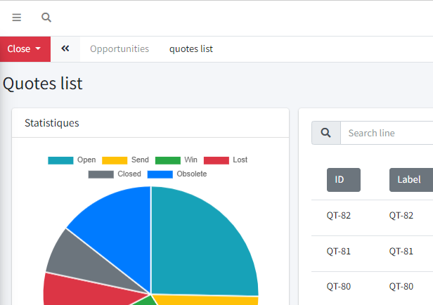
if Iframe mode on WEM #297

Add internal & External comment for lines #293
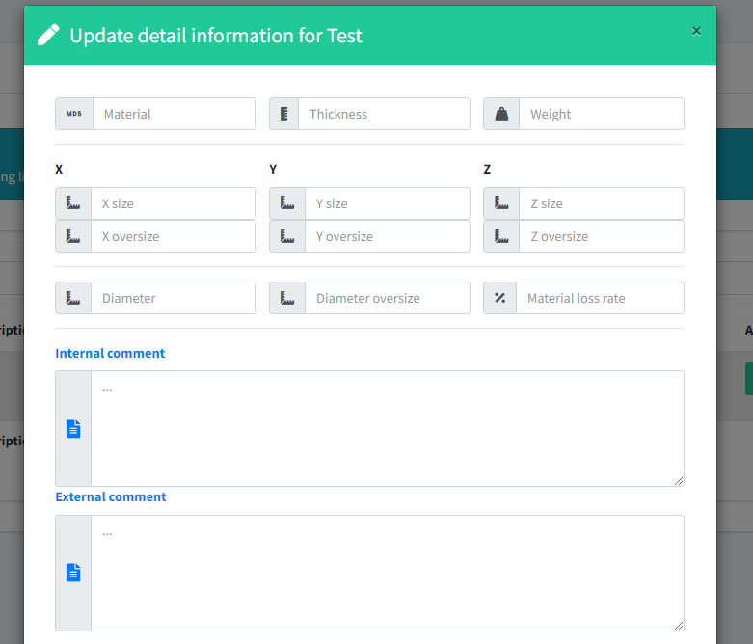

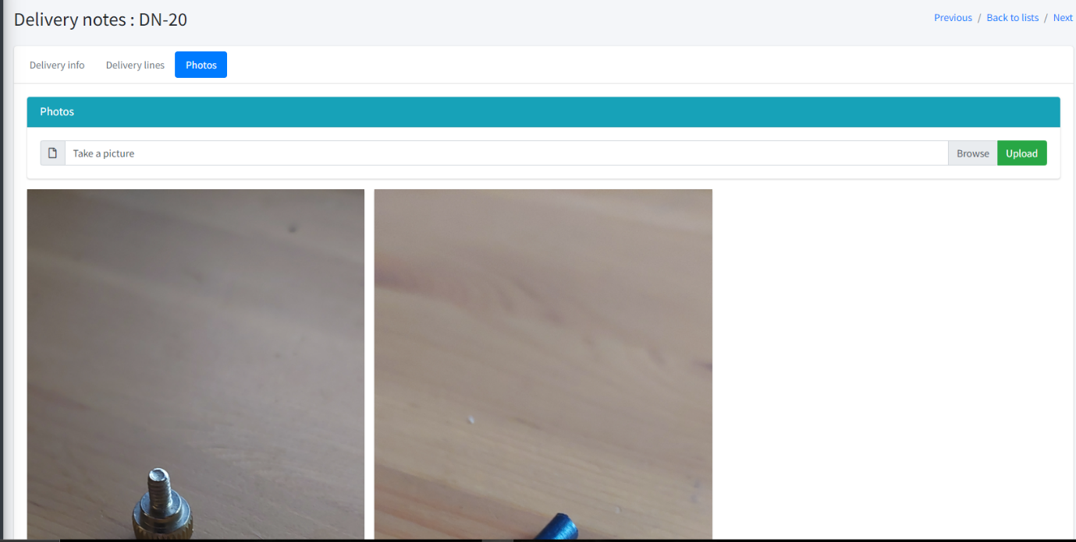
Take photo of packtage befor delevery #290

General Conditions of Sale (CGV) #294
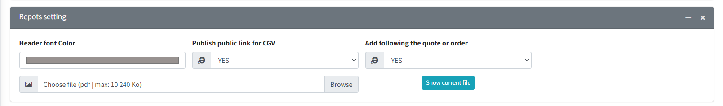
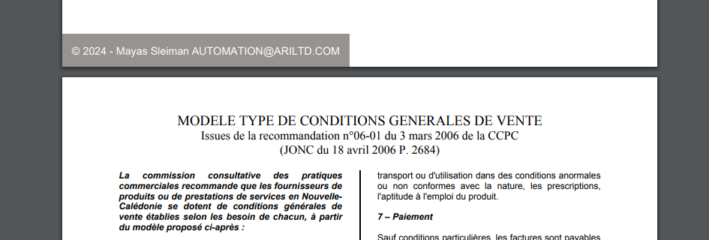
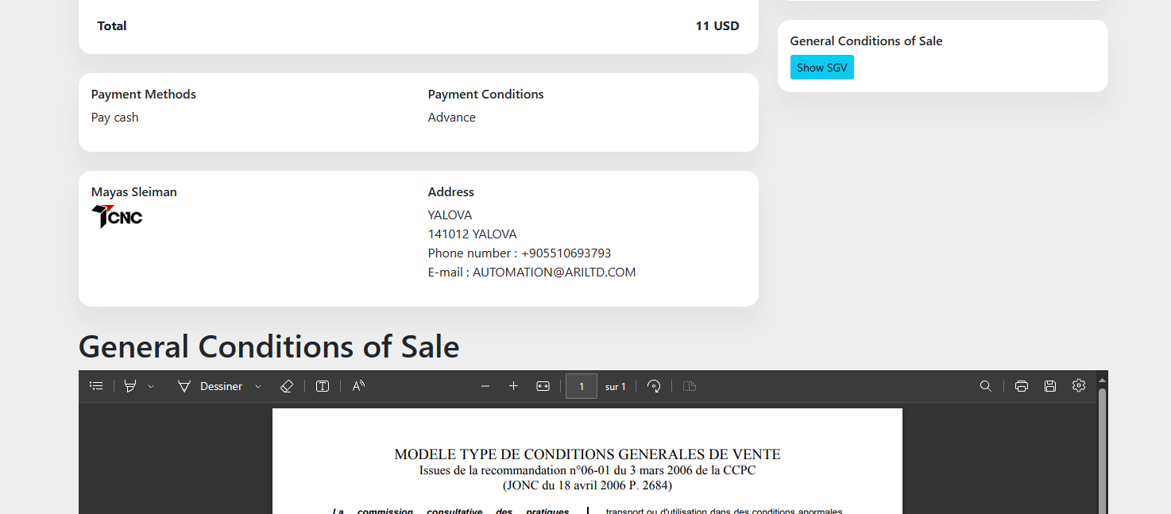

Ad drawing file of product #308
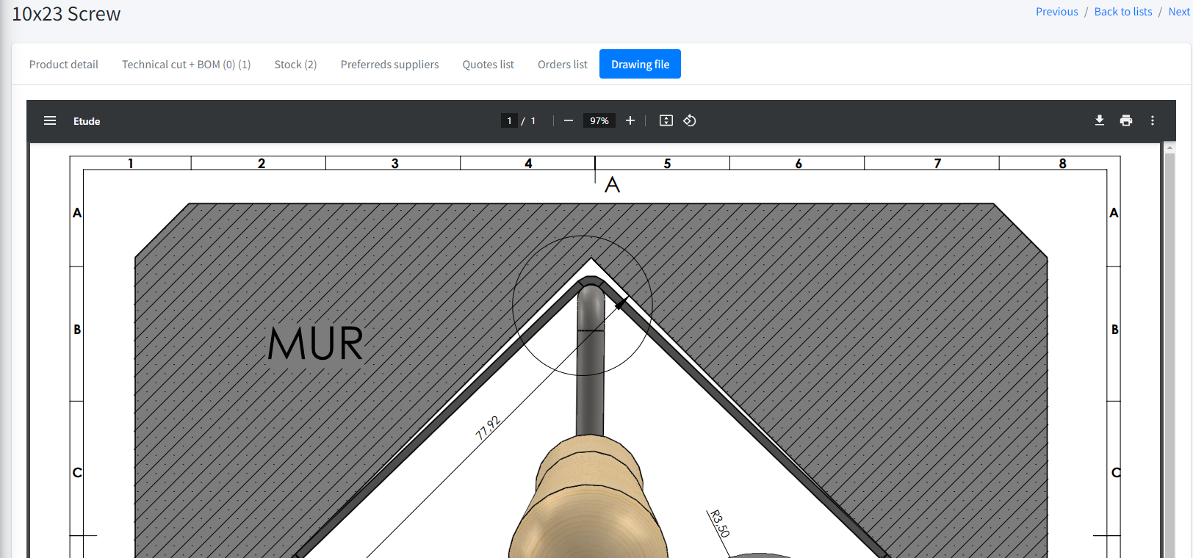

Add preferred supplier #313

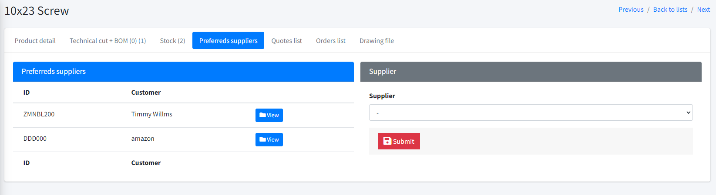

In purchase requests, display only the products concerned by the supplier #314

Make same UI from Task list to purchase and problem with conversions #315

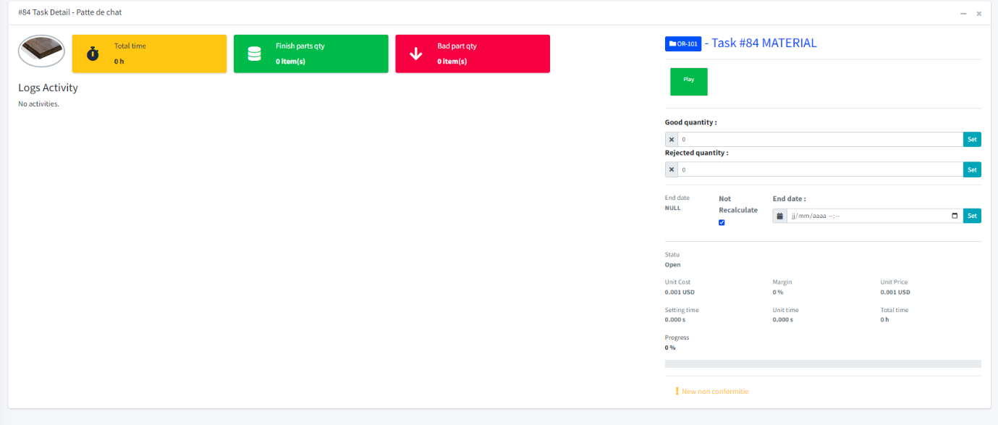
No productive task, change UI #316

change statu if is an internal order #323
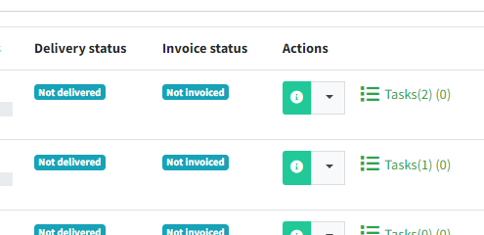

Create red case if all stock are low #319
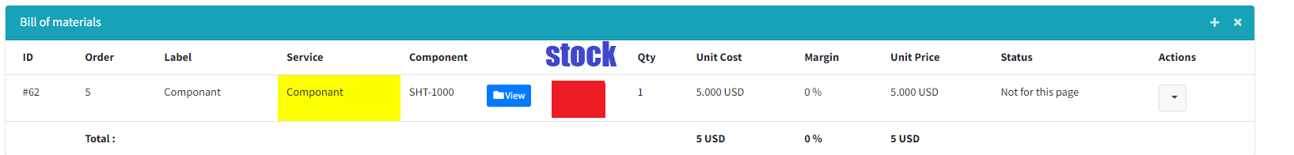

Display of stocks and requirements #321
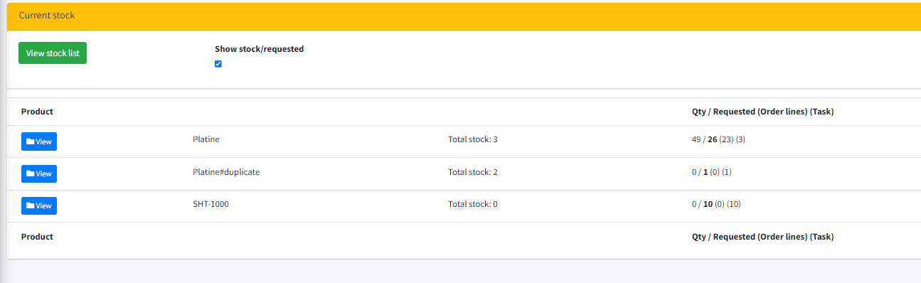

Change statu workflow, if is and internal order #327

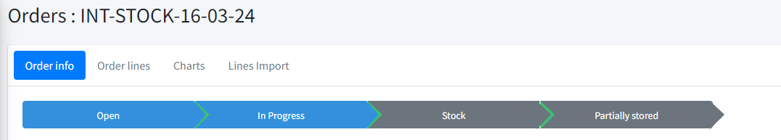

Create purchase order, if stock for component is low as needed #320

Desactivate new order button, if need is null #332
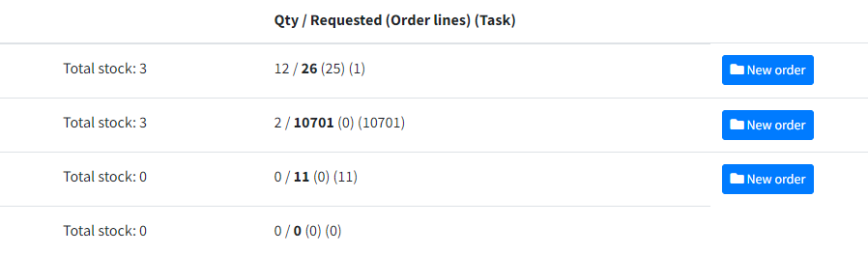

Create in/out stock #318

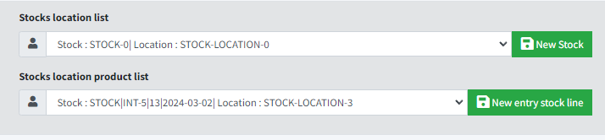
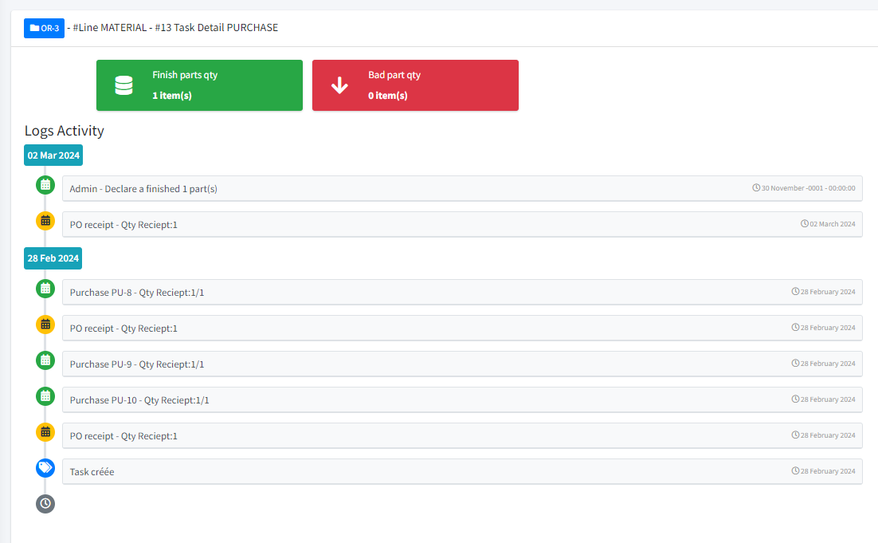
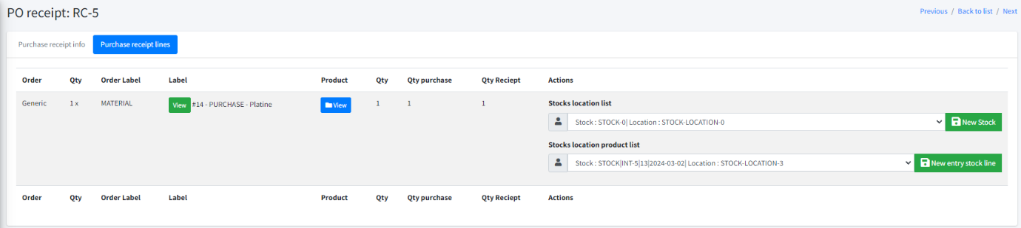
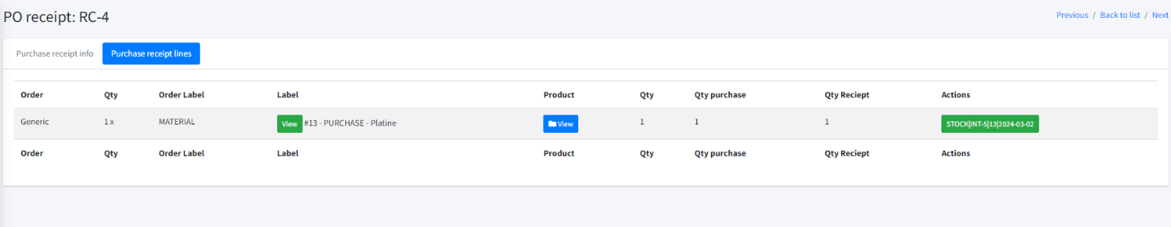
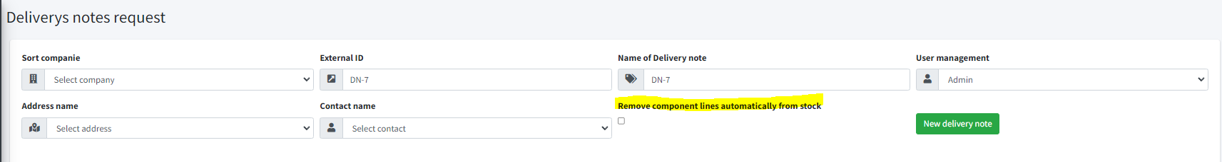
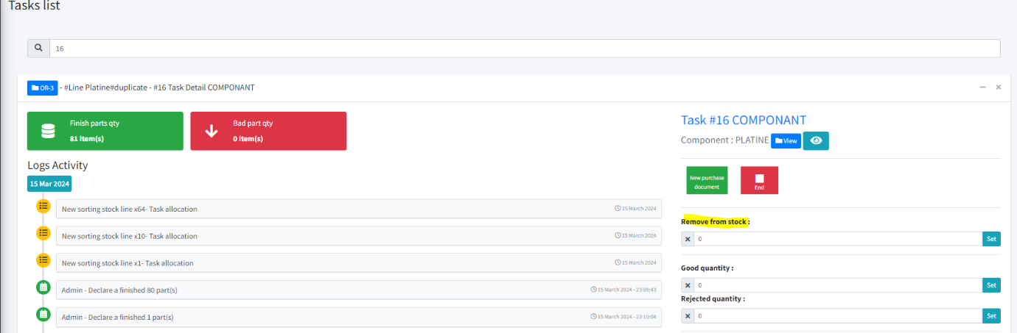

Be able to manage tasks for sub-assembly #334
